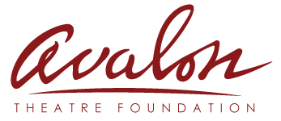
Application for Board Membership
Please fill in the following information and return to:
Avalon Theatre Foundation
Attn: Board Development Committee
PO Box 2243
Grand Junction, CO 81502
Date: _____________________

Contact Information:
Name:

First Middle Initial Last

Home Address: ________________________________________________________________________

Mailing Address (if different): _____________________________________________________________

Home Phone__________________________ Work Phone (optional) ____________________

Cell Phone ____________________________ Email __________________________________________

Easiest way to contact me ________________

About Me (Please use the back of the page if needed to complete):

Have you served on boards or committees for other organizations? If yes, please list:

What are your goals for serving as Avalon Theatre Foundation Board Member?

What role do you think the Avalon Theatre Foundation should serve in the community?

What special strengths, talents, or skills can you bring to the Avalon Theatre Foundation Board?

Which of the following areas interest you and why? _____ Finance _____ Grant Writing
_____ Marketing _____ Fund Raising _____ Special Events _____ Long Range Planning & Development

Please attach a brief biography and/or resume. Thank you for your interest in the Avalon Theatre Foundation.

